Usability testing

Usability testing is a test in which whether a user achieves the intended functional goal using a system or not and the level of effort involved to use the system\cite{iso:9126}. The success of a usability test is dependent on the goal of the usability test. A usability test should have a specified goal, a carefully prepared questionnaires, appropriate techniques and tools to be of any use. The most frequently used method of conducting a usability test is based on four notable lines\cite{usability:doc2}\cite{usability:doc3}

Efficiency – time to complete task

Effectiveness – task completed ratio

Learnability – number of errors recorded for novice

Memorability – browsing and searching time for non- regular users.

Another method of measuring user attitude towards a system is TAM.

TAM, technology acceptance model, is a tool with which users general perceived of use, perceived ease of use and intention to use is measured, while usability testing is more focused on task based performance of users\cite{tam:doc4}. TAM is based on a twelve question model in which 3 things are measured

1. PU – Perceived usefulness
2. PEU – Perceived ease of use
3. ITU – Intention to use

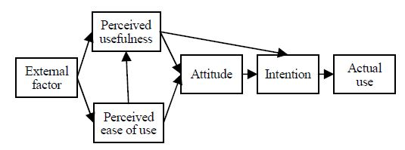

Figure Technology acceptance model framework[2]

In this project, we will be using a revised version of the usability test we described above, especially focusing on effectiveness and efficiency. Artsdatabanken has an already web experience user base and the number of novice users might probably not be significant to measure memorability and learnability of the system.

To measure performance and perception with regard to the system, the team will use a post questionnaire in the form the three TAM categories.

Source Doc2

1. ISO9126

2. The relationship between technology acceptance model and usability test, Chiou, Wen-Chih, Perng, Chyuan Lin, Chin-Chao, WASW International conference on Information Engineering, 2009

3.Usability of complex information systems, Evaluation of user interaction, Michael J. Albers, Brian Still, CRC Press, 2011

4. F.D Davis, R.P. Bagozzi, and P.R. Warshaw, “User acceptance of computer technology: a comparison of two theoretical models, Management Science, 1989